Bangladesh University of Professionals



Faculty of Science and Technology
Department of Information & Communication Technology (ICT)

Course Title: Industrial Training

Course Code: ICE-3211

Submitted by

Section – A, Batch: BICE – 2022

Name: Nasrat Jahan
ID:2254901061
Walton ID: IA-539
Submission Date: 07.05.2026

Direct to the project folder

Creating and Starting all the Container
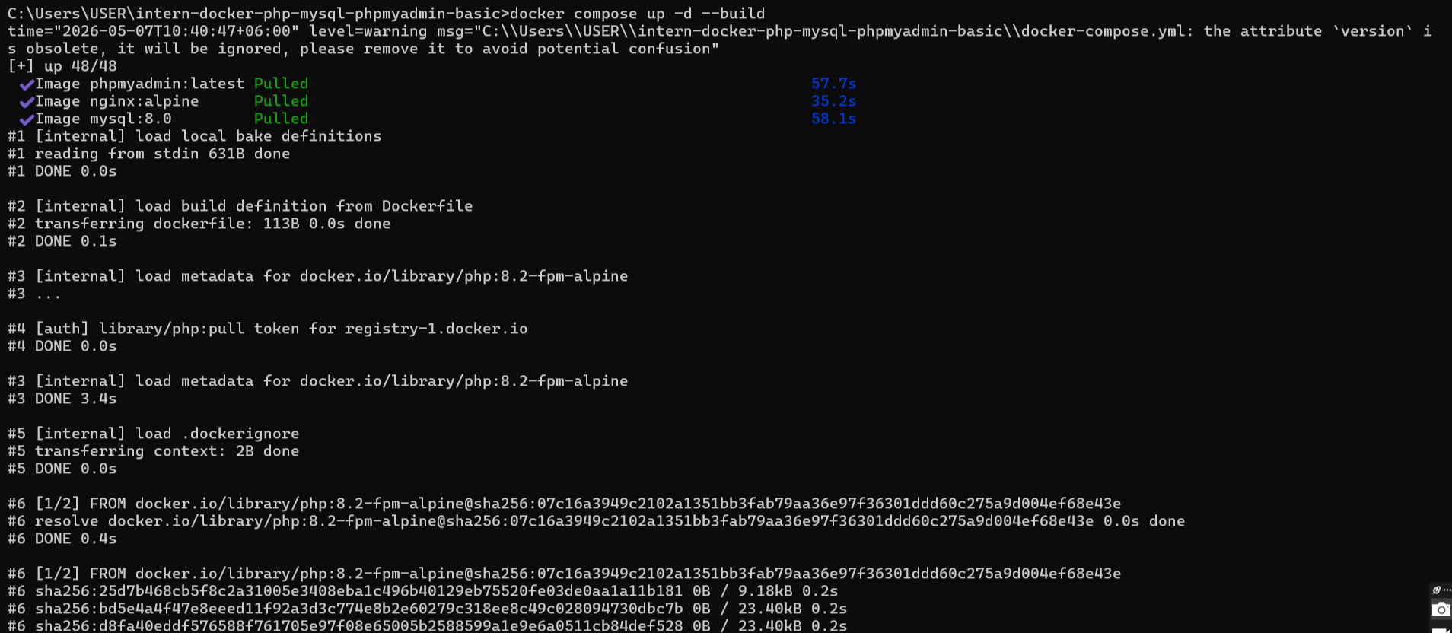

Check if container has started or not
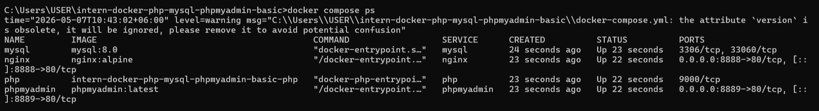

Main Application
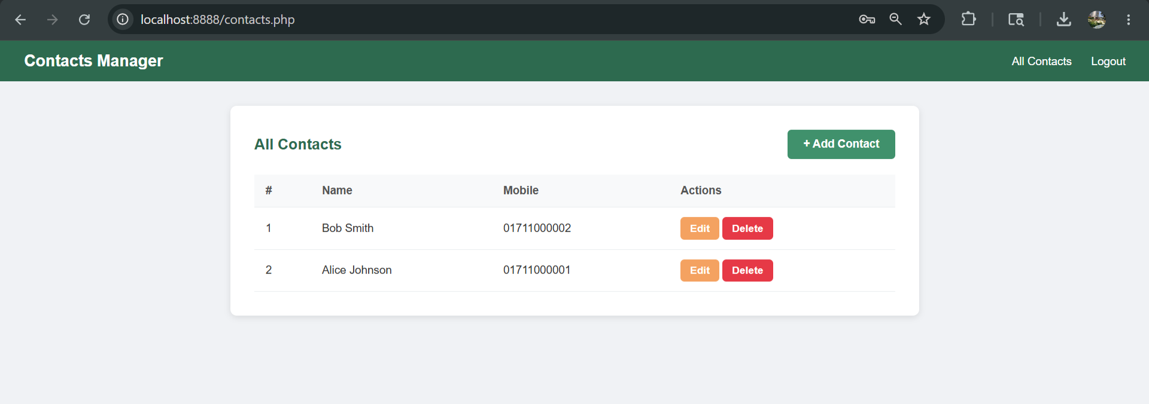
Add contact
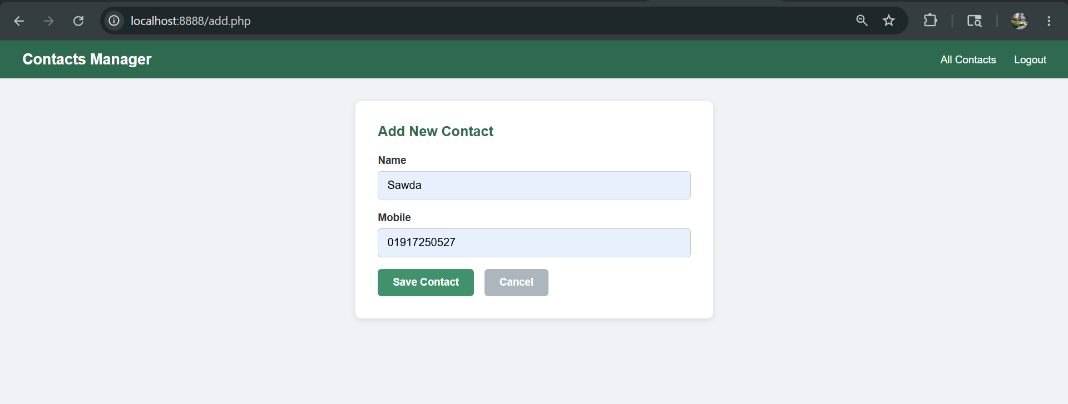

Edit Contact
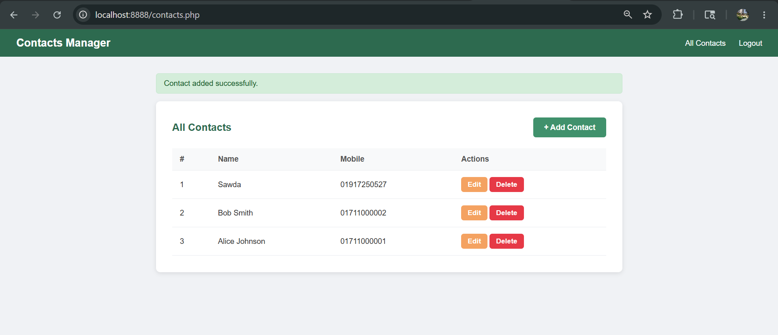
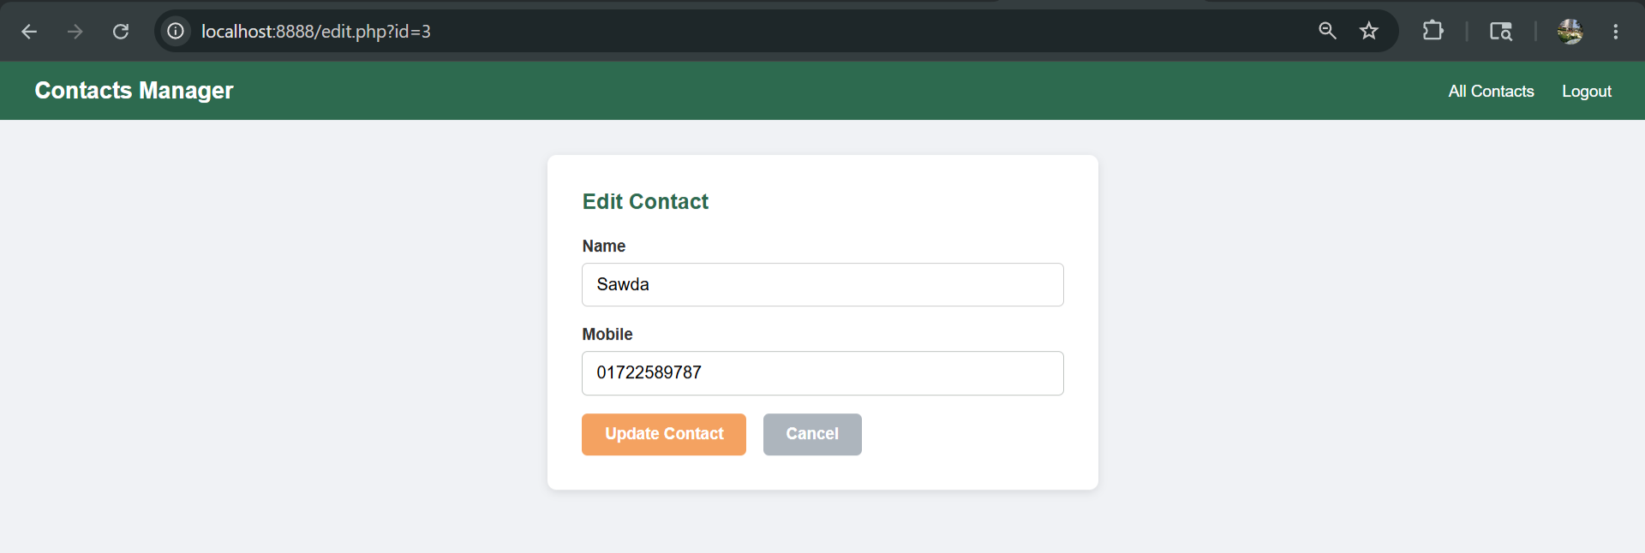

Delete contact
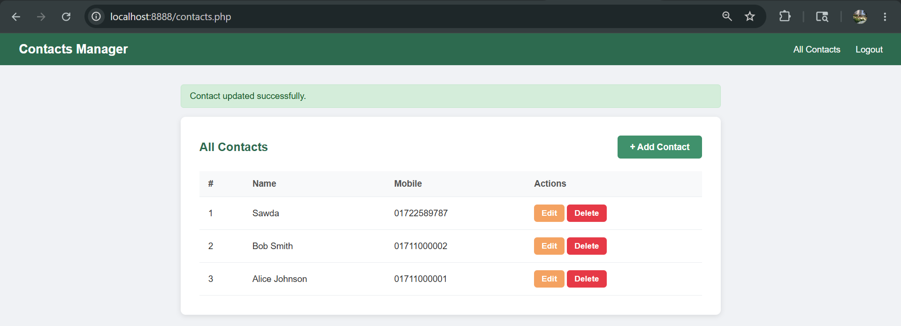
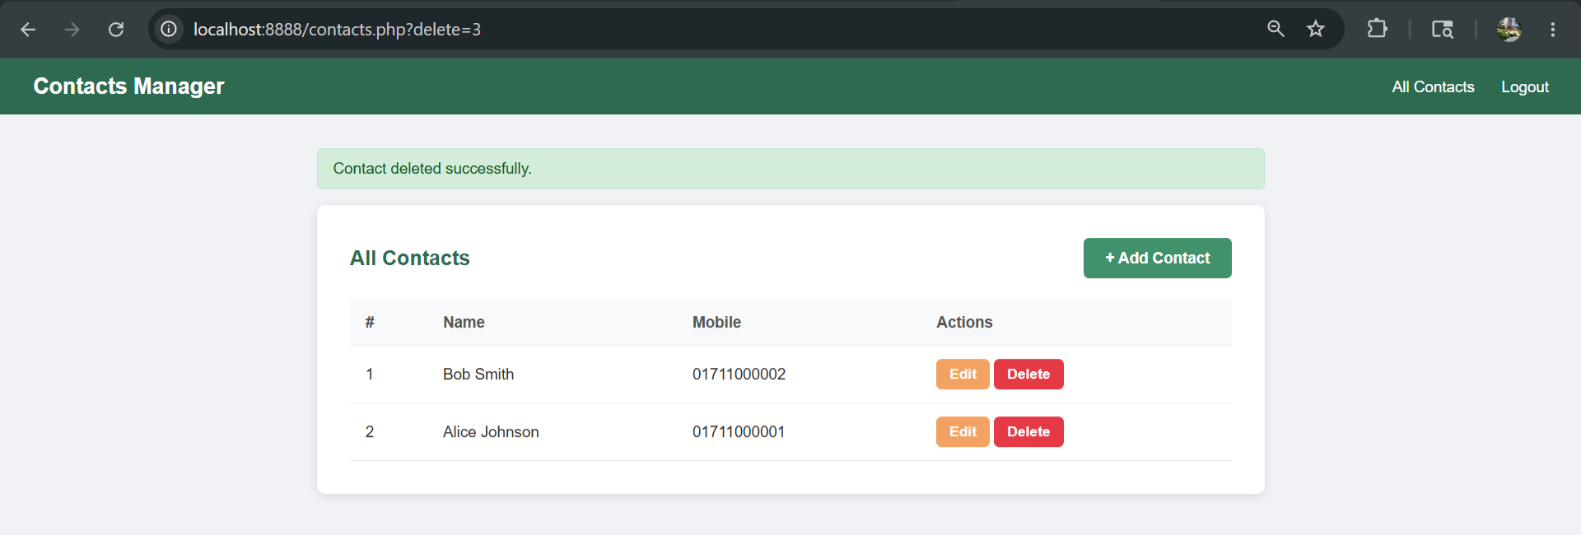

Database Structure
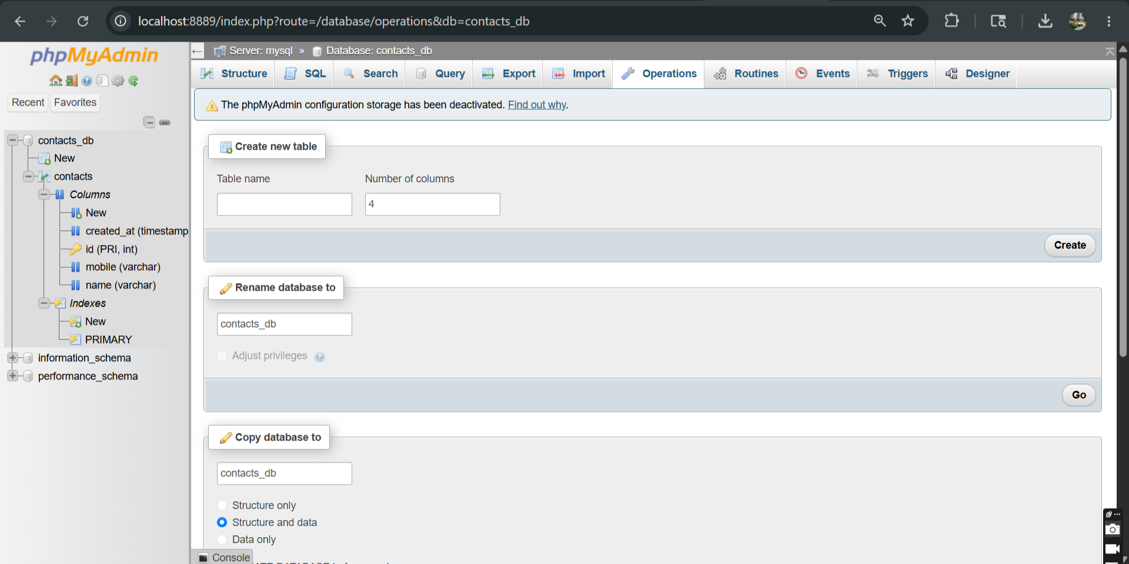
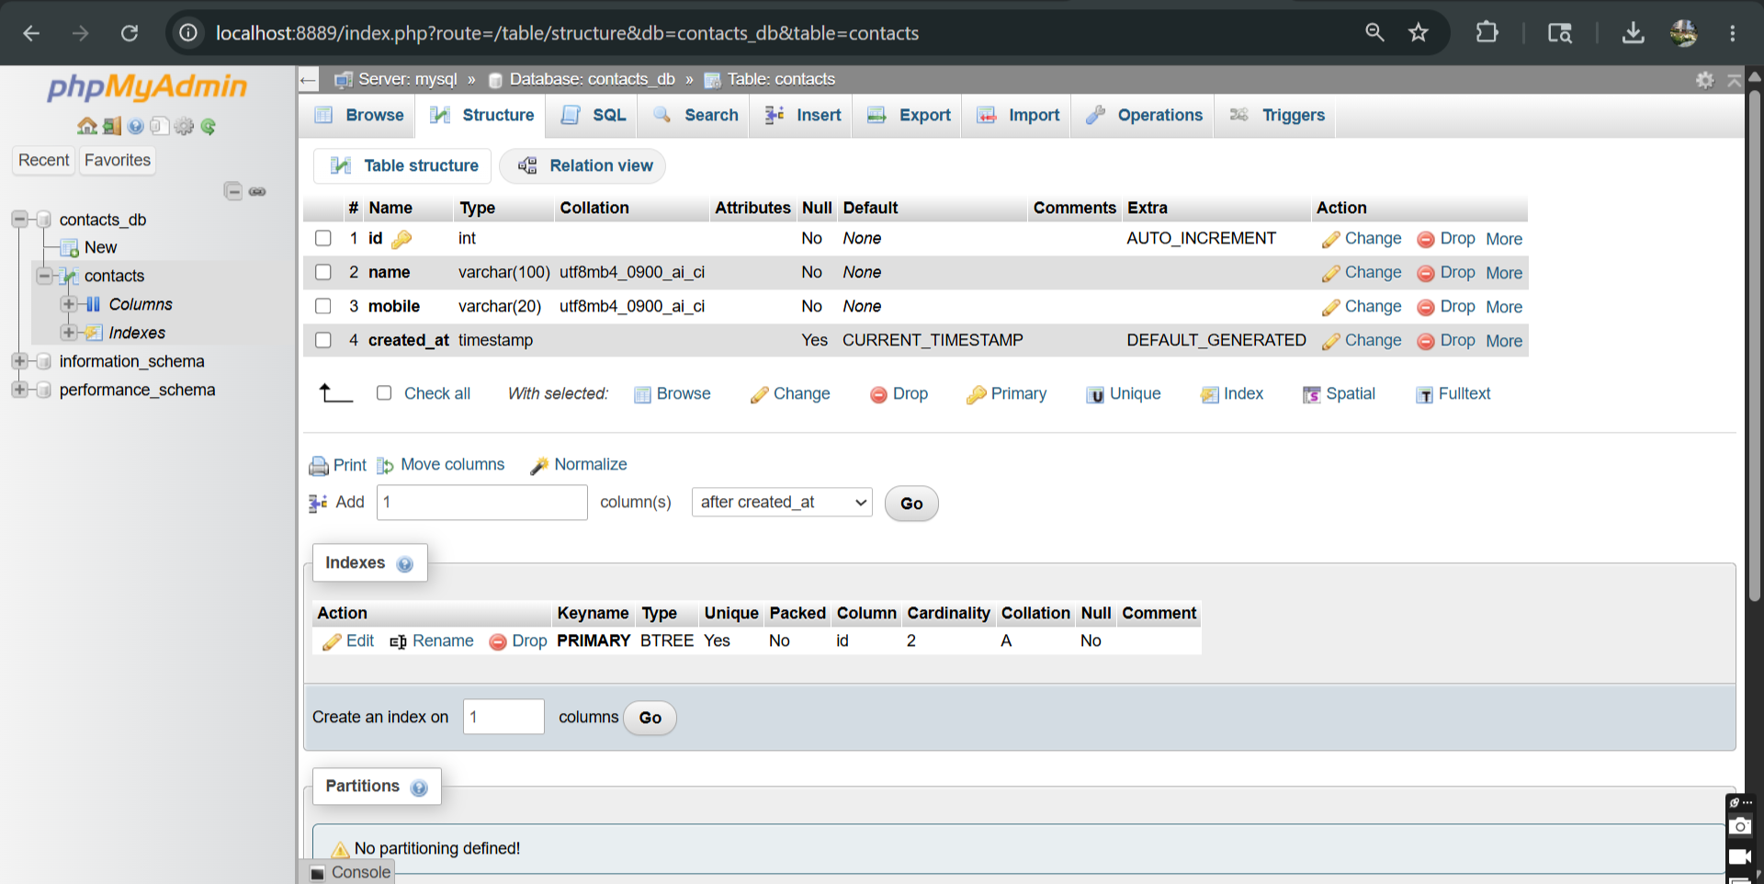
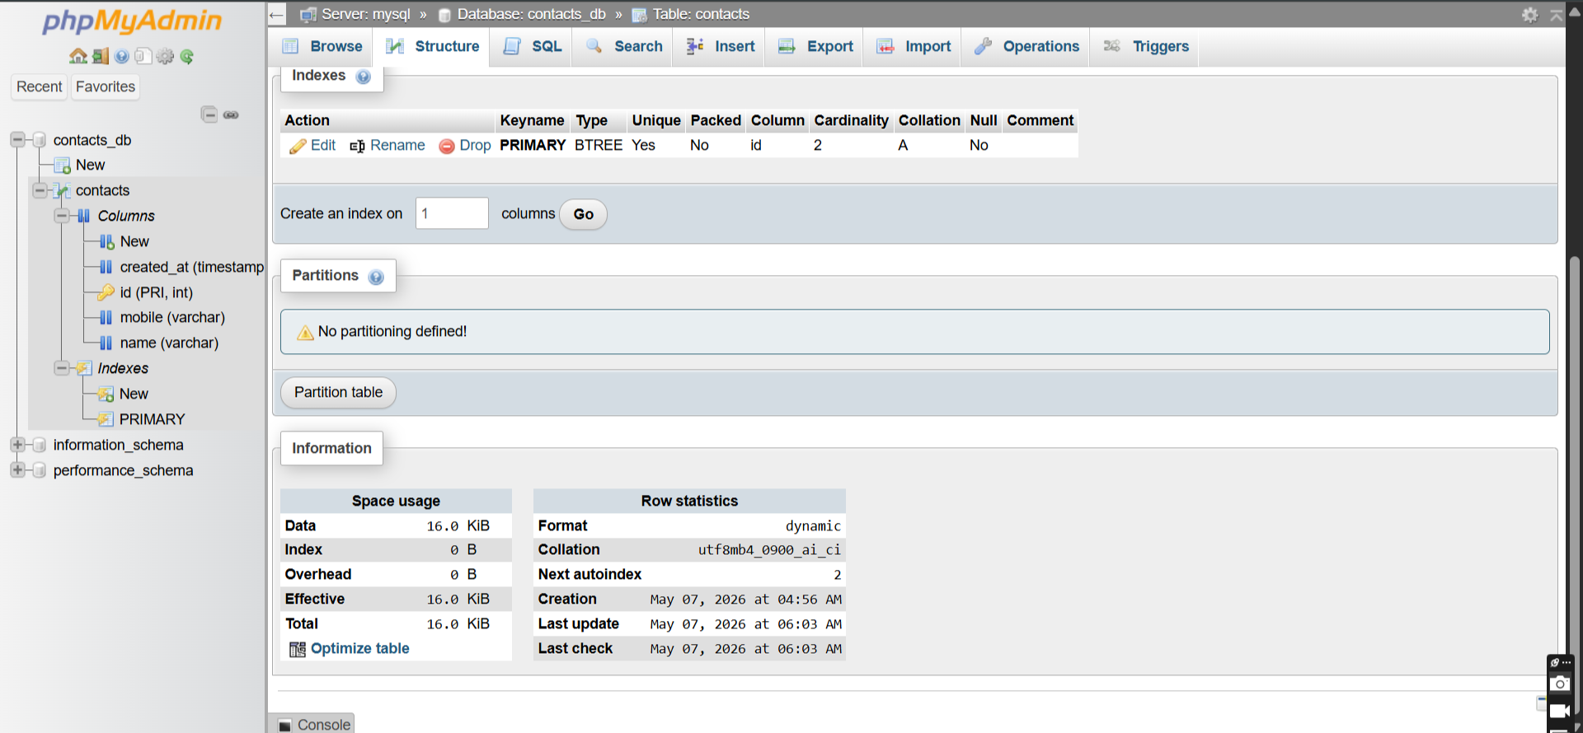
View Live logs
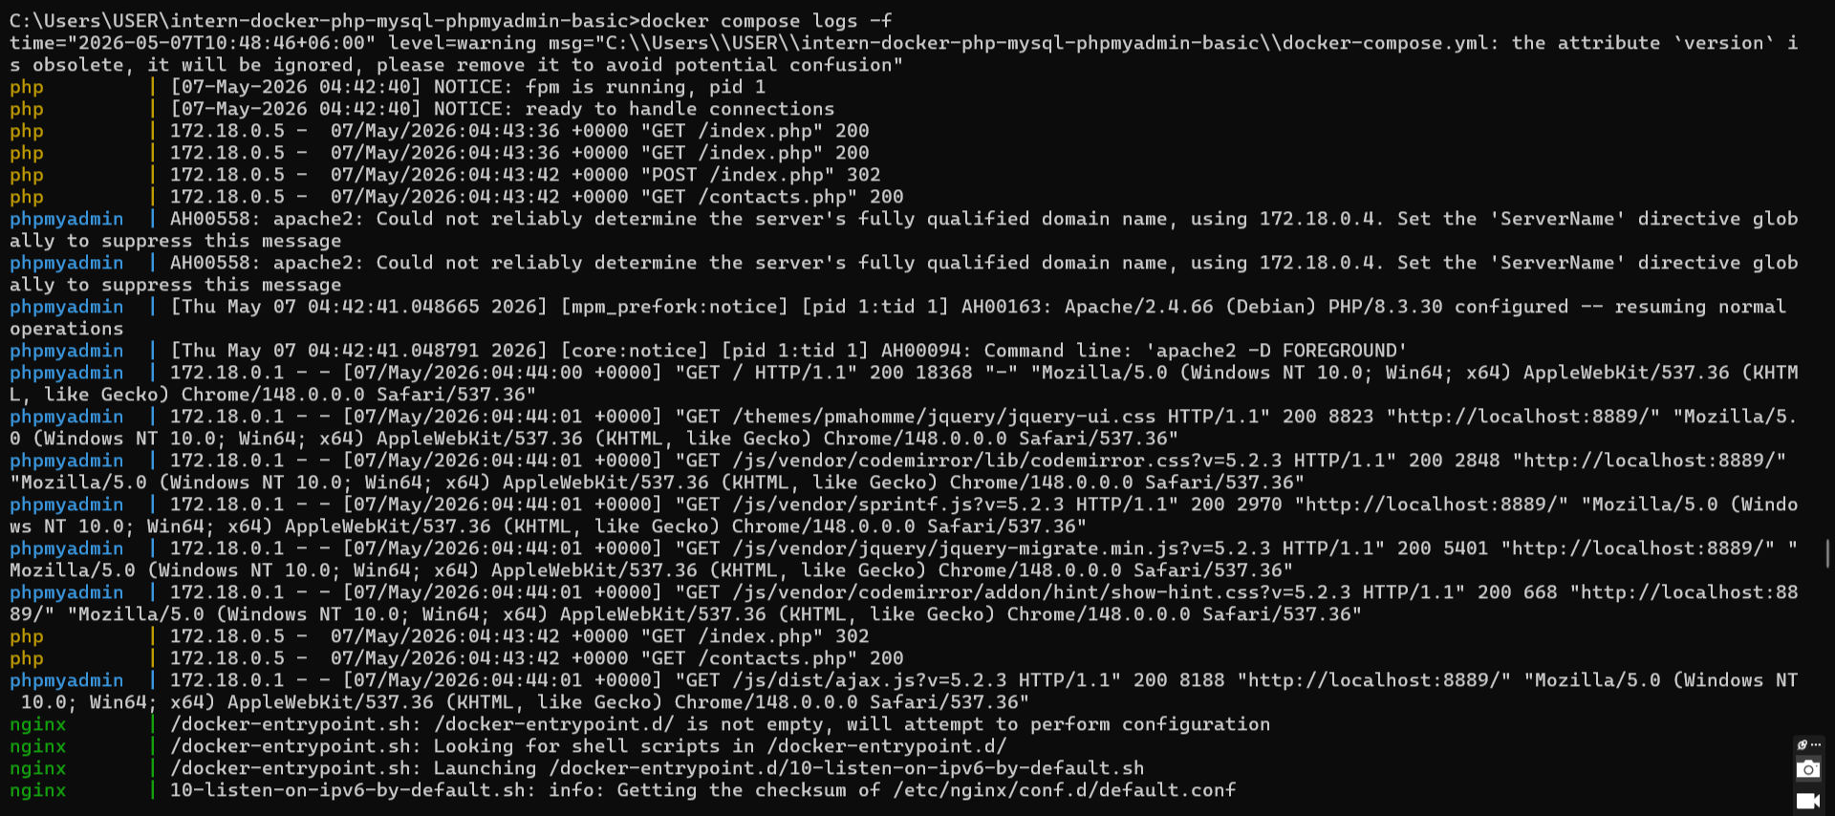
View logs of one container at a time

Nginx,
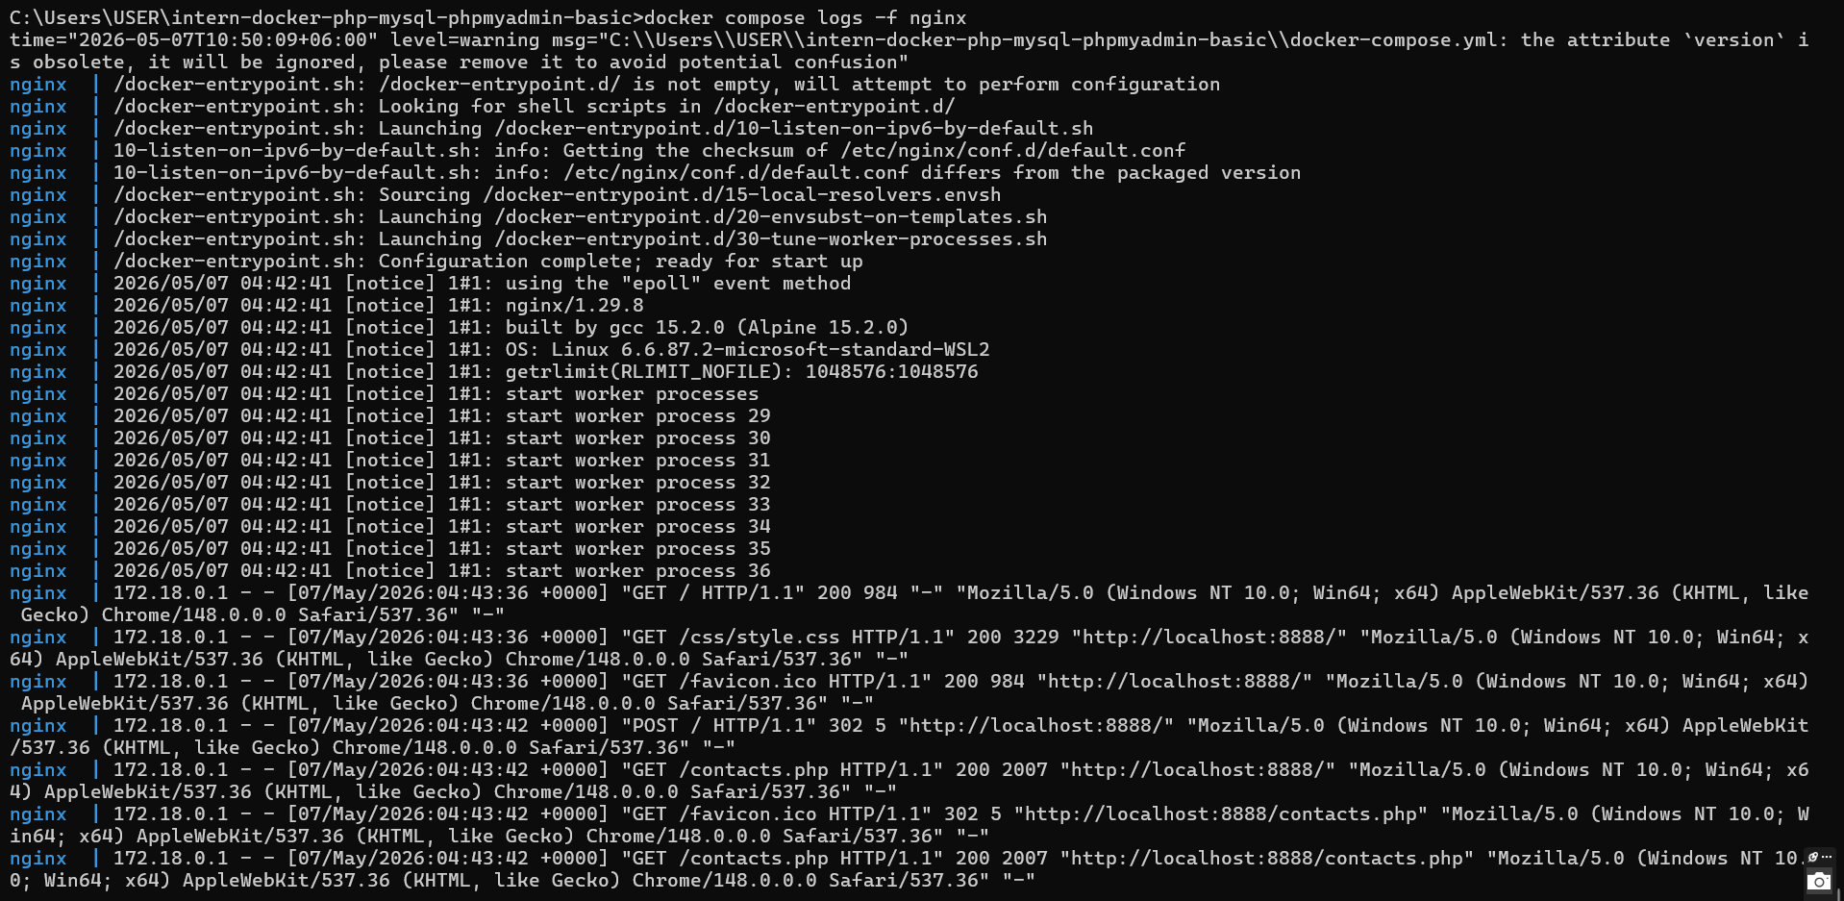

PHP,
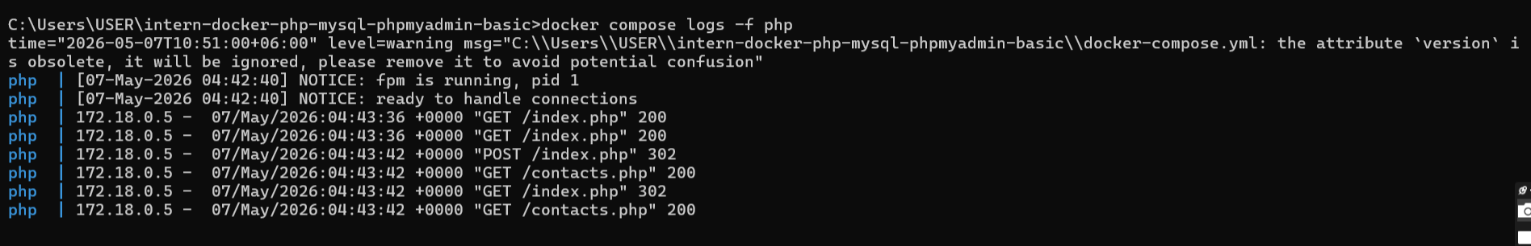

Mysql,
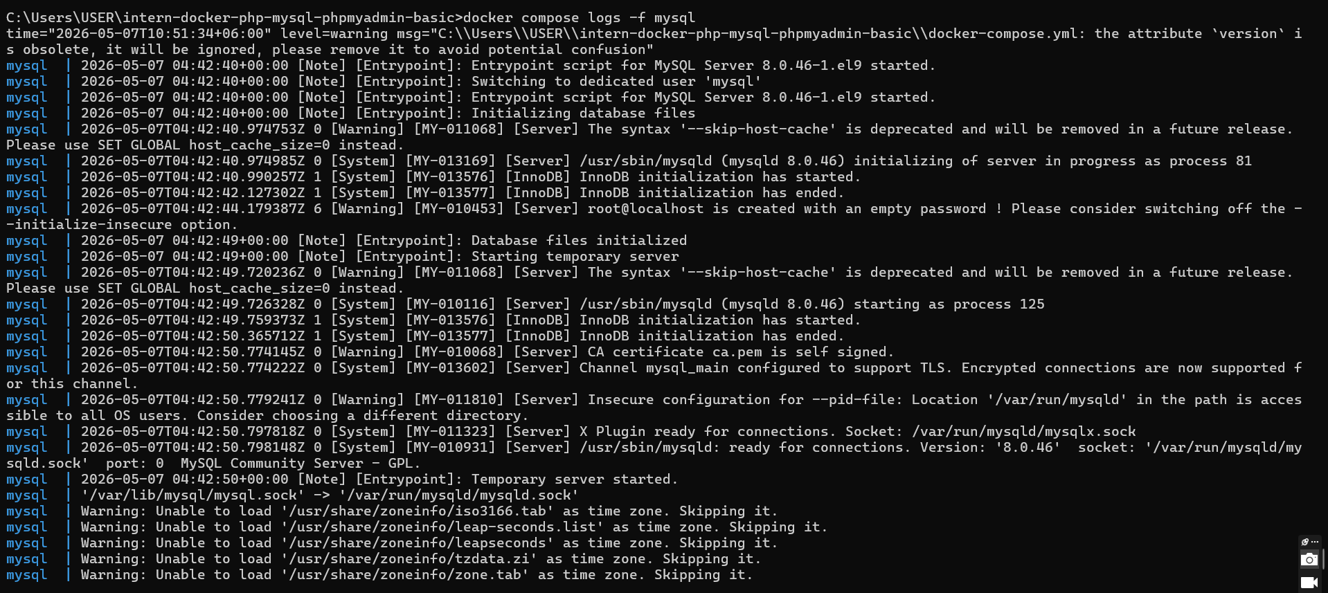

Stop all containers
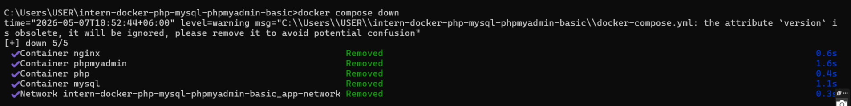

Stop and DELETE all data

Restart everything

Force rebuild from scratch
